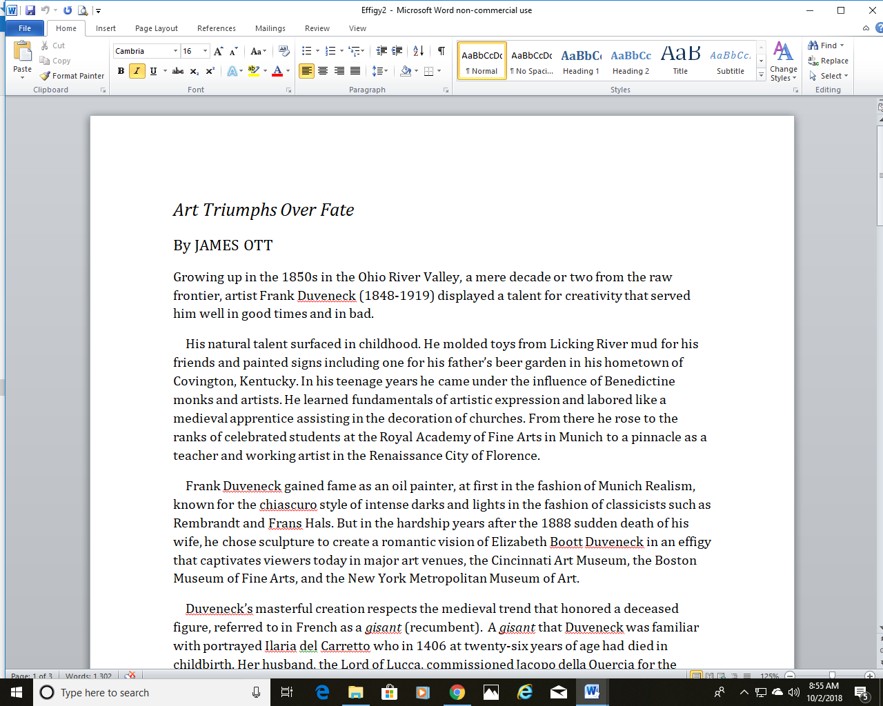Art Triumphs Over Fate
By JAMES OTT
Growing up in the 1850s in the Ohio River Valley, a mere decade or two from the raw frontier, artist Frank Duveneck (1848-1919) displayed a talent for creativity that served him well in good times and in bad.
His natural talent surfaced in childhood. He molded toys from Licking River mud for his friends and painted signs including one for his father’s beer garden in his hometown of Covington, Kentucky. In his teenage years he came under the influence of Benedictine monks and artists. He learned fundamentals of artistic expression and labored like a medieval apprentice assisting in the decoration of churches. From there he rose to the ranks of celebrated students at the Royal Academy of Fine Arts in Munich to a pinnacle as a teacher and working artist in the Renaissance City of Florence.
Frank Duveneck gained fame as an oil painter, at first in the fashion of Munich Realism, known for the chiascuro style of intense darks and lights in the fashion of classicists such as Rembrandt and Frans Hals. But in the hardship years after the 1888 sudden death of his wife, he chose sculpture to create a romantic vision of Elizabeth Boott Duveneck in an effigy that captivates viewers today in major art venues, the Cincinnati Art Museum, the Boston Museum of Fine Arts, and the New York Metropolitan Museum of Art.
Duveneck’s masterful creation respects the medieval trend that honored a deceased figure, referred to in French as a gisant (recumbent). A gisant that Duveneck was familiar with portrayed Ilaria del Carretto who in 1406 at twenty-six years of age had died in childbirth. Her husband, the Lord of Lucca, commissioned Jacopo della Quercia for the work. Jocopo presented her as a woman of self-sacrifice, her hands holding her swollen stomach.
Duveneck’s effigy, produced in clay in the Cincinnati studio of a friend, sculptor Clement Barnhorn, served several purposes. The act of creating assuaged his grief and in a tangible way kept her memory alive. For the same reasons his father-in-law, Francis Boott, commissioned a marble version for the Boston museum where he and Duveneck’s son, his grandson, could view it often. The sculpture served as a springboard for the grandfather to tell personal stories of Elizabeth to the little fellow, Frank Jr. On his frequent visits to Boston, the artist-father also relayed memories to the boy who was reared there by Elizabeth Boott’s Lyman family relatives.
The deceased mother became a living presence to the boy, “an unseen but intimate reality,” as the painter’s daughter-in-law Josephine Whitney Duveneck put it in her biography, Frank Duveneck, Painter-Teacher.
In 1895, the Paris Salon awarded the marble sculpture an honorable mention.
The effigy may be viewed in other forms. The Met in New York City displays a gold-leaf bronze version in Gallery 700 of the Fifth Avenue location. A practical application of the bronze effigy is the sarcophagus over Mrs. Duveneck’s grave in the Cimetero Evangelico degli Allori in Florence. The accurate first-cut of the clay model is a feature of the Duveneck Room at the Cincinnati museum which is among a dozen organizations preparing monthly programs in 2019 to commemorate the centenary of the artist’s death, January 3, 1919.
Duveneck’s effigy becomes all the more poignant when considering the disparate lives of the artist and his artist-patrician wife. She, a Brahmin born in Boston and an heiress of the Boott Mills fortune, was reared in Europe under her father’s care, a cultured and polished “hot-house flower,” according to biographer Leon Edel. Duveneck came from German immigrant stock, Roman Catholic and family oriented, earnest and always busy trying to make a living. From a social standpoint they were hardly a match.
The elder Mr. Boott respected Duveneck’s talent and approved of him as his daughter’s art teacher. He was dead set against any union. Author Henry James, a close friend of Elizabeth Boott, joined with other friends and family in opposition. James found Duveneck pleasant, likeable and talented but uneducated and illiterate. Against this phalanx of opposition, Lizzie as she was known and Frank became engaged. In short order the betrothal ended. There followed a neurotic relationship consumed by anxiety over the separation, even an extended illness for Lizzie. Clandestine meetings, likely in art venues in Europe and America, maintained the spark of romantic love.
Love won out. As Lizzie was embarking on a steamer returning to Europe, Duveneck, persistent all along, proposed. He cautioned her that the offer for her hand would be his last. To his relief she consented. They worked out an arrangement for the geriatric Mr. Boott to live with them. The marriage took place in March, 1886, in Paris. An idyllic period followed in the spacious Villa Castellani in Florence where Mr. Boott and Lizzie had resided previously. The little family rejoiced when Lizzie delivered Frank Jr., born in December of 1886, and all was well between them.
Lizzie is credited with having a head for business. She urged a move to Paris, the pulsating center of the new artistic style known as Impressionism. Frank would gain from the experience, she wrote to a friend, adding, “One also sees so much that is interesting and profitable.” By this time Duveneck had attained a somewhat glamourous position in the art world. American art magazines enthused over him and his students, the Duveneck Boys, largely in articles by artist-writers Joseph and Elizabeth Robins Pennell. A taste of glamour came their way when celebrated author William Dean Howells fictionalized Duveneck as the teacher Englehart and wrote of the popularity of the Englehart Boys in his 1888 novel of American expatriates, Indian Summer.
This world came crashing down on a cold and rainy day in late March, 1888. On a shopping trip Lizzie was seized by a chill and took to her bed. She had caught a fatal case of pneumonia, succumbing five days later. Duveneck languished in grief as he and his father-in-law, child Frank Jr. and Elizabeth’s long-time nurse maid and companion, Ann Shenstone, followed Elizabeth’s remains to Florence for burial. He slowly pulled himself together and spent much of the early 1890s traveling and working on the effigy. In 1894 he visited Italy and performed final touches on the bronze sarcophagus in the Florence cemetery.
Always admired for his oil portraits and landscapes—he was called “the greatest brush” of their generation by John Singer Sargent—Duveneck produced several other sculptures on commission. The images of author Ralph Waldo Emerson and Charles Eliot, the former president of Harvard University, may be seen today at the university. The effigy of his wife, however, endures as one of Duveneck’s best known works, a sterling example of how something beautiful and good may arise from tragedy.
The Elizabeth effigy won eloquent endorsements from the author Henry James and his brother, the philosopher and psychologist William James. After viewing it at Allori Cemetery, William wrote, “All I can say is that it is beautiful, beautiful, beautiful! The face with its solemn half-smile, the position of the head, the hands upon the somewhat flattened form as if sunk into the couch, the simple, delicate drapery, so modest and so real, the serenity and piece of the whole thing!”
At first somewhat critical of the work, author James later grew admiring and philosophical. In a letter to Mr. Boott, James wrote: “One sees in its place and its ambiente, what a meaning and eloquence the whole thing has—and one is touched to tears by this particular example which comes home to one so—of the jolly great truth that it is art alone that triumphs over fate.”
James Ott is the author of The Greatest Brush, Love, Tragedy and Redemption of Artist Frank Duveneck, published in 2016 by Branden Books of Boston.

